Title: | Door Control Module  SW Component ActuatorManager

History
Issue status  (Index) | Maturity/Date  (draft/invalid/valid)  (dd-mmm-yyyy) | Author  Department | Check/Release  Department | Description
1.0 | Draft  02-Feb-21 | Rubén Cocoletzi | - | Initial Version

Table of Contents
1 Purpose 3
2 Definitions and abbreviations 3
3 Realization constraints and targets 3
4 SW Conceptual design 4
5 SW Component internal breakdown 4
5.1 Functional Decomposition 4
5.2 Function void SensorManager_Init (void) 5
5.3 Function void GetAdcCounts (int* AdcCounts) 5
5.4 Function void SensorManager_Reading (void) 5

Purpose
This document is created to show the principal behavior of the functions implemented in ActuatorManager to control output pins

Definitions and abbreviations
Definitions
NA

Abbreviations
References
N° | Document name | Reference
1 | SW Architecture description | Commit: ddc45822a03f9f1781eaa4fc5b6d5874311f8e1b

Realization constraints and targets

This document shows the principal implementation to control output pins.

SW Conceptual design
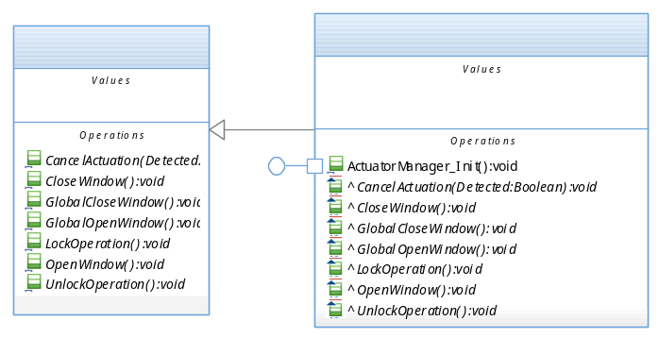

SW Component internal breakdown

Functional Decomposition
Overview of functions and their dependencies shown by a Static Function Tree
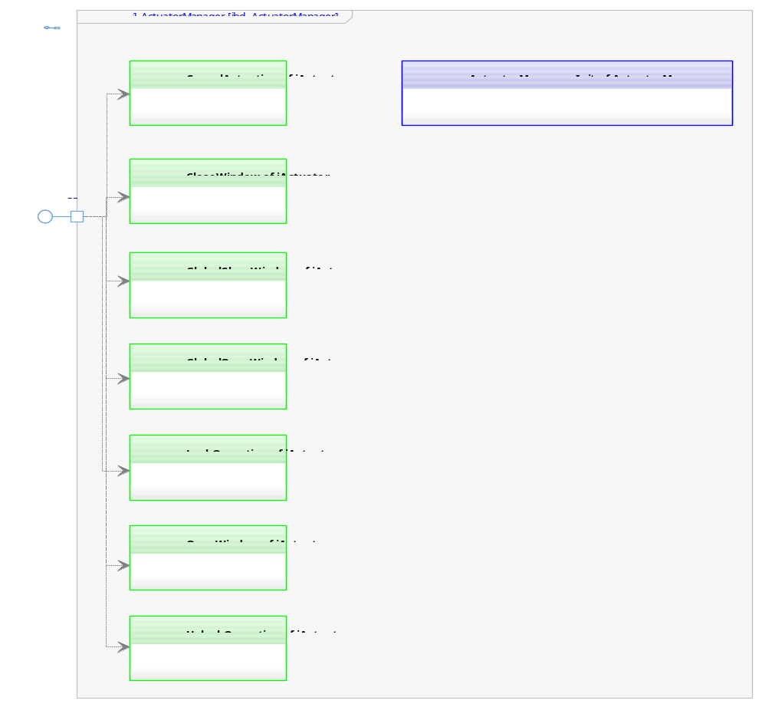

Function Description and Dynamic Behavior

Function void CancelActuation (void)

Description | This function is used to control output pin to open the corresponding window
Parameter 1  <input| output| inout> | NA – Not identified yet
Parameter 2..n | NA – Not identified yet
Return Value | void
Precondition | Function is called by the Window software component only when an object was detect by Antipinch sensor
Post condition | Window shall open.
Error Conditions | NA – Not identified yet
Requirements | NA – Not identified yet

Function void CloseWindow (void)
Description | This function is used to control output pin to close the corresponding window
Parameter 1  <input| output| inout> | NA – Not identified yet
Parameter 2..n | NA – Not identified yet
Return Value | void
Precondition | Function is called by the Window software component
Post condition | Window shall close.
Error Conditions | NA – Not identified yet
Requirements | NA – Not identified yet

Function void GlobalCloseWindow (void)
Description | This function is used to control output pin to close the corresponding window
Parameter 1  <input| output| inout> | NA – Not identified yet
Parameter 2..n | NA – Not identified yet
Return Value | void
Precondition | Function is called by the Window software component
Post condition | Window shall close.
Error Conditions | NA – Not identified yet
Requirements | NA – Not identified yet

Function void GlobalOpenWindow (void)
Description | This function is used to control output pin to open the corresponding window
Parameter 1  <input| output| inout> | NA – Not identified yet
Parameter 2..n | NA – Not identified yet
Return Value | void
Precondition | Function is called by the Window software component
Post condition | Window shall open.
Error Conditions | NA – Not identified yet
Requirements | NA – Not identified yet

Function void OpenWindow (void)
Description | This function is used to control output pin to open the corresponding window
Parameter 1  <input| output| inout> | NA – Not identified yet
Parameter 2..n | NA – Not identified yet
Return Value | void
Precondition | Function is called by the Window software component
Post condition | Window shall open.
Error Conditions | NA – Not identified yet
Requirements | NA – Not identified yet

Function void LockOperation (void)
Description | This function is used to control output pin to lock the corresponding door.
Parameter 1  <input| output| inout> | NA – Not identified yet
Parameter 2..n | NA – Not identified yet
Return Value | void
Precondition | Function is called by the Door software component
Post condition | Door shall lock.
Error Conditions | NA – Not identified yet
Requirements | NA – Not identified yet

Function void UnLockOperation (void)
Description | This function is used to control output pin to unlock the corresponding door.
Parameter 1  <input| output| inout> | NA – Not identified yet
Parameter 2..n | NA – Not identified yet
Return Value | void
Precondition | Function is called by the Door software component
Post condition | Door shall unlock.
Error Conditions | NA – Not identified yet
Requirements | NA – Not identified yet

Function void ActuatorManager_Init (void)
Description | This function is used to configure the corresponding pins as digital outputs
Parameter 1  <input| output| inout> | NA – Not identified yet
Parameter 2..n | NA – Not identified yet
Return Value | void
Precondition | This function is called by OS
Post condition | The corresponding pins shall be configured as digital outputs
Error Conditions | NA – Not identified yet
Requirements | NA – Not identified yet

